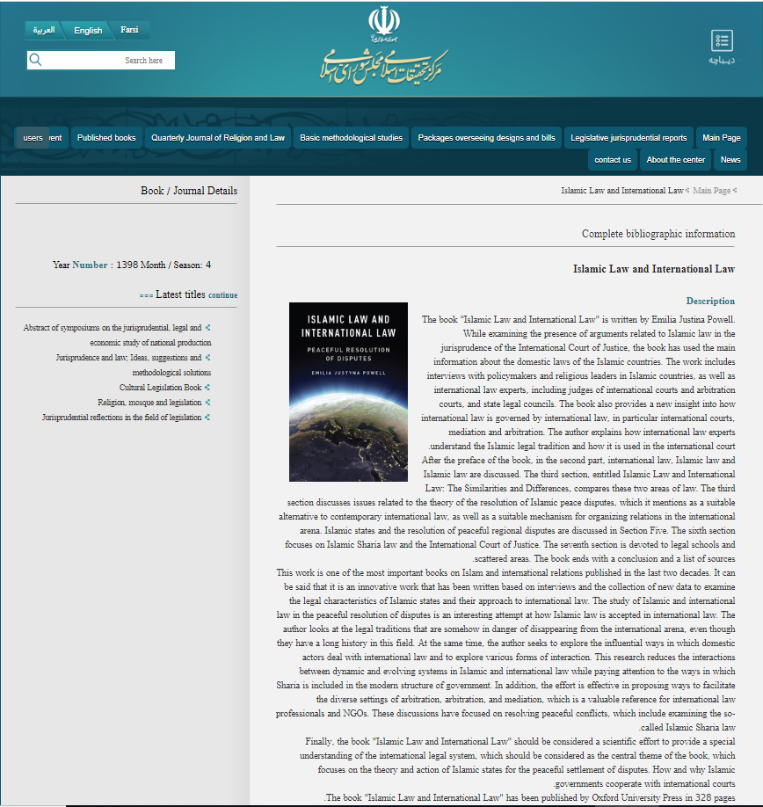

http://cmirq.ir/fa/book_pub/show/2427

